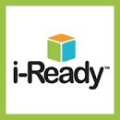

🙞 🙜

Iready is a program that provides data on domains specific material for your students.

Progress monitors your student.

Provides online differentiated instruction so student can fill in gaps for missed skills.

Provides BOY/MOY/EOY date to analyze growth and possible outcomes.

🙞 🙜

Lakeisha Holliday

RDNG/501

# Moby Max

# [www.mobymax.com](http://www.mobymax.com)

## Iready Diagnostic

<https://login.i-ready.com/>

Your Assessment Directory Guide

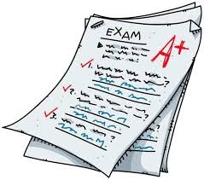

### Instructor: Sarah Carrasco

### July 27, 2020

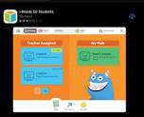



Moby Max is a formal assessment that differentiated to the students academic needs.

*Pinpoints skills missed in previous grades.

*Provides Goals for students to achieve.

*Incentives for passing levels.

*Progress monitors students progress.

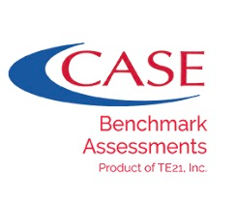

Case 21 is a formal assessment that provides data from standards learned per quarter.

Drives your instruction.

Good use for Corrective Instruction

Shows score per correct standard.

Provides DOK knowledge.

Shows were re-teaching needs to take place.

Includes: *Standardized testing

*WIDA

*Unit Exams

*End of Grade Testing

*Formal assessments tend to be more structured.

*They inform you of knowledge learned throughout the year or quarterly.

*Modifications are used for specific students.



Exit tickets provide you with immediate results of student’s progress.

Written Response gives you a description of the students writing to see if they understood learned concepts.

Projects help the students gain knowledge in a creative way.

Quizzes give feedback on standards taught. Provides data for re-teaching.

# Informal Assessments

Includes: Quizzes

*Projects

*Written Responses

*Exit Tickets

*Informal Assessments are more flexible within the classroom setting.

*They inform you of who needs more support.

*They are continuous though out the year.

## Informal Assessments